Kickstart Analysis

1. What are three conclusions we can make about Kickstarter campaigns given the provided data?
   * 1. Theater is the category with the most Kickstarts.
     2. Theater has the most successful Kickstarts.
     3. Music has the highest percentage of successful Kickstarts.
2. What are some of the limitations of this dataset?
   * 1. Date format is not very useful and requires manipulation.
     2. Some Kickstarts start at $1 and exceed their goals. This causes outliers and can skew averages.
     3. Data does not track the outcome of the Kickstart. I would like to see of the successful Kickstarts how many actually started and completed their purpose of the Kickstart.
3. What are some other possible tables/graphs that we could create?

A pivot tables that shows the number of Backers in each Status on a per Category. This will show the interest of the sample population. Per pivot table below, Technology has the highest Backers despite the successful percentage of this category. 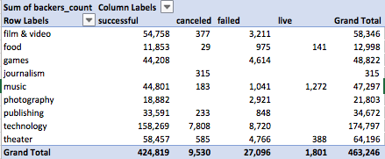

A pivot table that counts how many were in Spotlight to determine the percentage of the total Kickstarts that are in Spotlight. The data shows that the category Theatre has 20% in Spotlight and might have an affect on amount pledge. 